Name __________________________________________________________________ Cells

Use the Cells Alive website to identify the organelles in the plant and animal cells below.
http://40two.info/barge/bio/cells.html

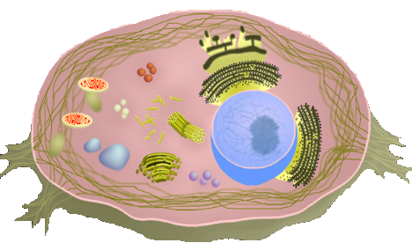

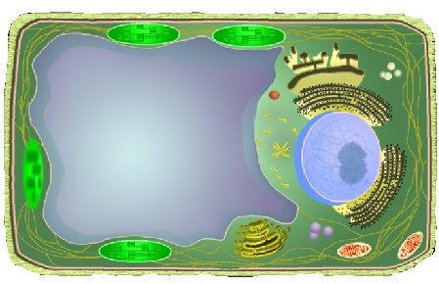

Eucaryotic Cell Organelles
Use the Cells Alive website to describe the organelles in the plant and animal cells below.

Nucleus:

Nucleiolus:

Cytosol:

Cytoplasm:

Centrosome:

Centriole:

Golgi:

Lysosome:

Peroxisome:

Secretory Vesicle:

Cell Membrane:

Mitochondria:

Vacuole:

Cell Wall:

Chloroplast:

Smooth Endoplasmic Reticulum:

Rough Endoplasmic Reticulum:

Ribosomes:

Cytoskeleton:

Procaryotic Cells
Use the Cells Alive website to identify and describe the organelles in the bacterial cell below.
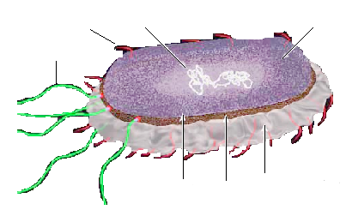

Internal Structure:

Nucleoid:

Ribosomes:

Storage granules:

Appendages:

Pili

Flagella

Visit the Cell Structure Interactive link to review cell organelles & try to construct a cell

Surface Structure:

Capsule:

Outer membrane:

Cell wall:

Periplasmic space:

Plasma membrane:

