TI-Nspire Instructions for Graphing Data Sets

We will be using the TI-Nspire to examine the relationship in a set of data that we collect.

1) Begin a new document
Press the home key, c, then Add Lists and Spreadsheets
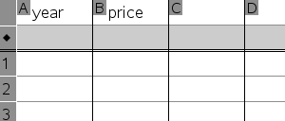
2) Enter data into the spreadsheet
length
time
40 1.22
40 1.62
60

Move up to the topmost cell in column (A) and type something like: length

Move to the topmost cell in column (B) and type something like: time

Fill column A with your lengths. Fill column B with the corresponding times. (Leave the gray colored row empty)

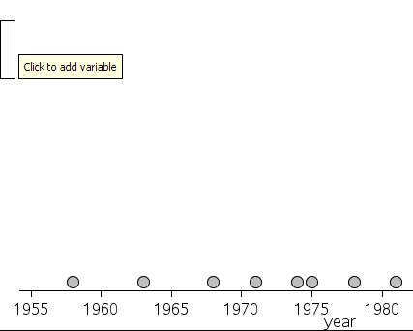
3) Creating a Scatter Plot
Press the home key, c, and move to Data and Statistics and hit enter. (Note: if this is not an option, your calculator may need an update!)
Move your cursor to the bottom of the page and click on “Click to add variable” then choose length.

On the left side of your screen, move your cursor to the y-axis and you will see the “Click to add variable” message. It should look like the image shown right.

Click it and choose time. Now we should have a graph of Length vs. Time.
length
To move between screens use the e and arrow keys →←
IMPORTANT:
Make sure that the graph begins at 0,0. It most likely will not do this automatically. You need to press the menu and choose the “Window/Zoom” then “Window Settings” option. In the pop up window set Xmin and Ymin to zero. You may also want to set the Ymax to be slightly larger than the biggest value.

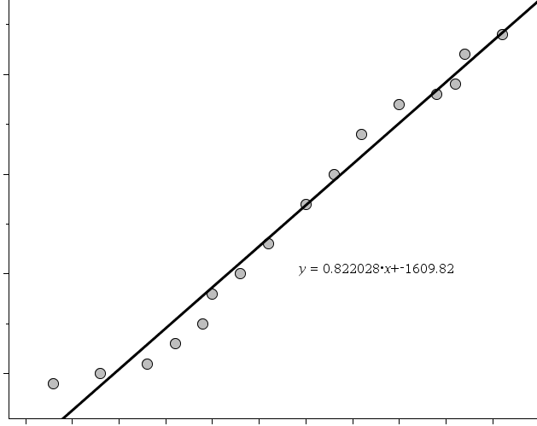

4) Getting the Equation of the Line
If your data shows a straight-line trend we can use the calculator’s “Regression” tool to find an equation that fits the data. (Our length vs. time may or may not look this way.)

Press:
Menu → Analyze → Regression → Show Linear (mx + b)

You should see an equation pop up on the scatter plot. Now all we have left is to figure out what the equation means, and how to use it.

