Name

Date Pd

Free Particle Model Worksheet 3:

Quantitative Force Analysis & Vector Components

1. Determine the tension in each cable below. Draw a force diagram for the system before solving the problem.
Case A - ball suspended on one cable Case B - ball suspended by two cables
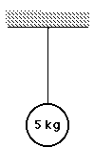

2. Determine tension in each cable.

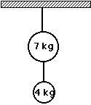

3. Find the horizontal and vertical components of the tension in the fishing line. Show your work.

38 N

4. A suspension bridge cable is connected to its anchor at a 20˚ angle. Draw a force diagram for the anchor, and then find the vertical and horizontal component forces on the anchor by the cable.

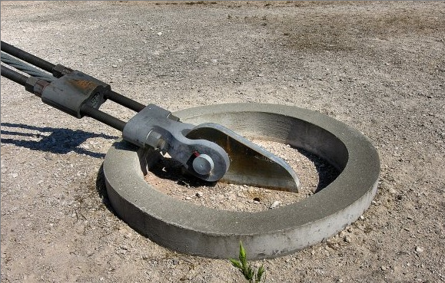
A real suspension bridge anchor

5. A rock sits on a hill. Draw a force diagram for the rock that allows you to determine how much of the rock’s weight is parallel to the hill, (that would tend to make it slide down the hill) and how much of the rock’s weight is perpendicular to the hill (that tends to hold the rock in contact with the hill.)

6. A 2000 kg elephant stands on a ramp. Draw a force diagram to determine the components of the elephant’s weight parallel and perpendicular to the ramp.

7. Tarzan prepares to swing and much to his dismay, gets his loincloth stuck on a branch. He's left hanging with the vine pulling upward at a 40-degree angle and his loincloth pulling him horizontally to the right.
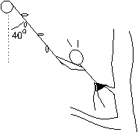
a. Draw a force diagram for Tarzan. Be sure to break angled forces into components and indicate which forces are equal with equality marks.

b. Write an equation for the vertical forces on Tarzan. (Look at your equality marks.)

c. Write an equation for the horizontal forces on Tarzan. (Look at your equality marks.)

d. Tarzan's mass is 75 kg. Calculate his weight.

e. Use the appropriate equation for the forces on Tarzan to determine the tension in the vine.

f. Determine the tension in his loincloth.

8. A 90 kg skier takes to the slopes and reaches a constant velocity.

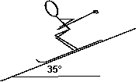
a. Draw a force diagram for the skier. (Hint: use a coordinate axis parallel and perpendicular to the hill's surface as in questions 5 and 6 on this worksheet.)

b. Determine the skier's weight.

c. Determine the component of the skier's weight that must be supported by the hill.

d. Determine the component of the skier's weight that pulls the skier down the slope.

e. What is the total force of friction and air resistance acting upon the skier? Explain how you know.

