1. Consider the position vs. time graph below for cyclists A and B.
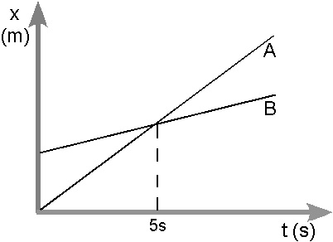

a. Do the cyclists start at the same point? How do you know? If not, which is ahead?

b. At t= 7s, which cyclist is ahead? How do you know?

c. Which cyclist is travelling faster at t = 3s? How do you know?

d. Are their velocities equal at any time? How do you know?

e. What is happening at the intersection of lines A and B?

2. Consider the new position vs. time graph below for cyclists A and B.

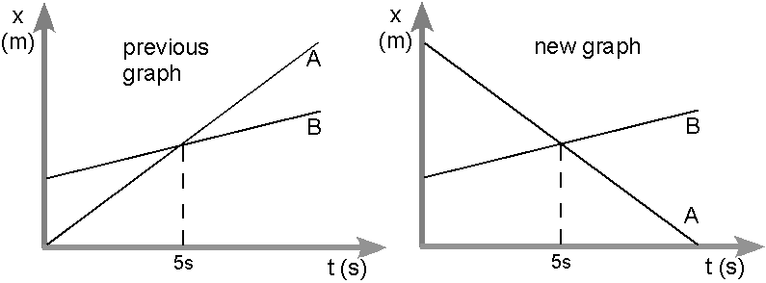

a. How does the motion of the cyclist A in the new graph compare to that of A in the previous graph from page one?

b. How does the motion of cyclist B in the new graph compare to that of B in the previous graph?

c. Which cyclist has the greater speed? How do you know?

d. Describe what is happening at the intersection of lines A and B.

e. Which cyclist traveled a greater distance during the first 5 seconds? How do you know?

3. Ranking Graphs
x (m)
t (s)
A
25
x (m)
t (s)
C
10
10
x (m)
t (s)
B
5
x (m)
t (s)
D
10
3
10
x (m)
t (s)
F
10
5
3
10
x (m)
t (s)
E
15
10
0
0
0
0
0
0
0
0
0
0
0
0
10
10

a. Rank the graphs according to which show the greatest displacement from the beginning to the end of the motion.

Most positive → 1______ 2______ 3______ 4______ 5______ 6______ ← Most negative

Explain your reasoning for your ranking:

b. Rank the graphs according to which show the greatest distance from the beginning to the end of the motion.

Greatest 1________ 2________ 3________ 4________ 5________ 6________ Least

Explain your reasoning for your ranking:

