Bar Graph Analysis of Various Modes of Energy Storage

For each situation shown below:
1. Show your choice of system in the energy flow diagram, unless it is specified for you.
**Always include the earth in your system.
2. Decide if your system is frictionless or not, and state this.
3. Sketch an energy bar graph for the initial situation.
4. Then complete the analysis by showing energy transfers and the final energy bar graph.

1. A car on a roller coaster track, launched by a huge spring, makes it to the top of the loop. The system is the spring, the earth and the car.

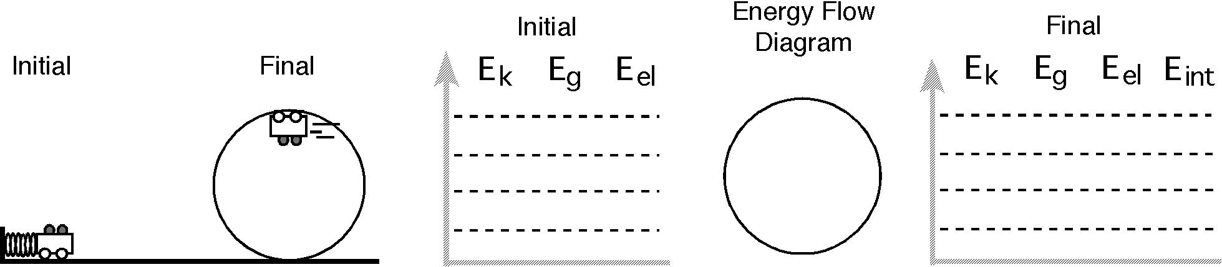

2. The same car is launched by the spring, but it is only half way up the loop. The system is the car and the earth.
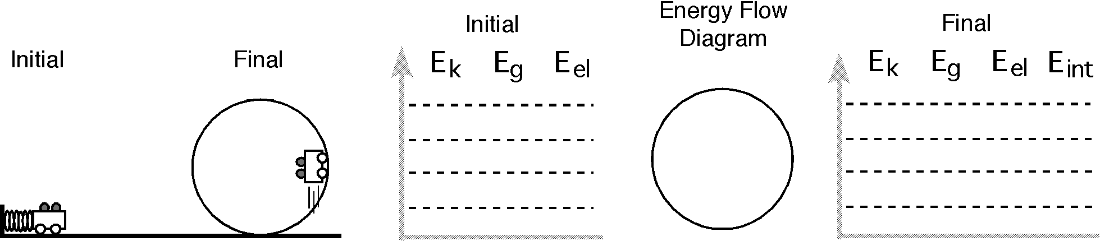

3. A moving car, moving up a hill, coasts to a stop.
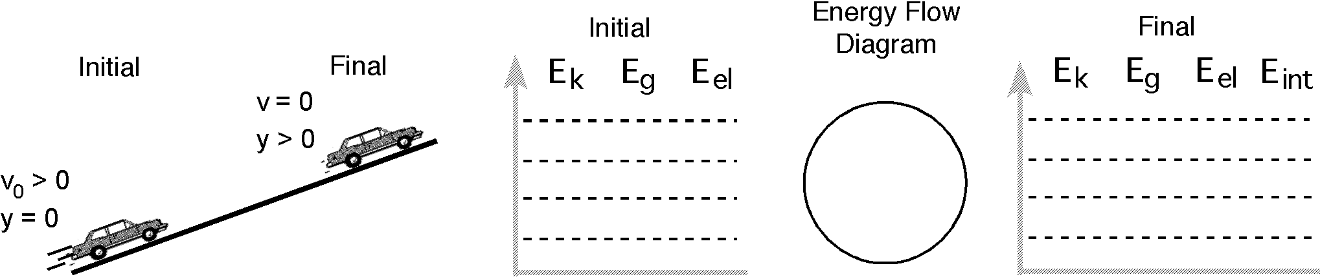

4. A person pushes a stalled car to get it to the service station.

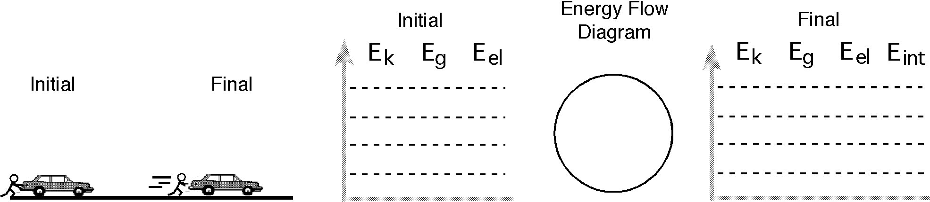

5. A load of bricks, resting on a compressed spring, is launched into the air.

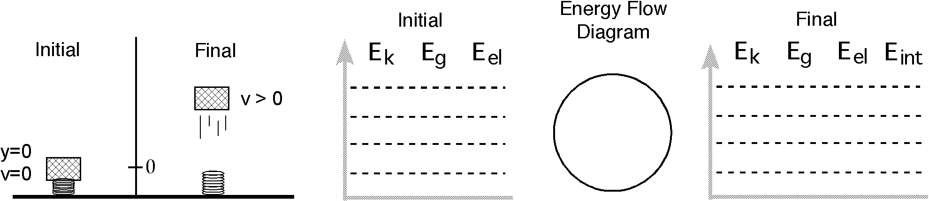

6. A crate, starting at rest, is propelled up a hill by a tightly coiled spring.

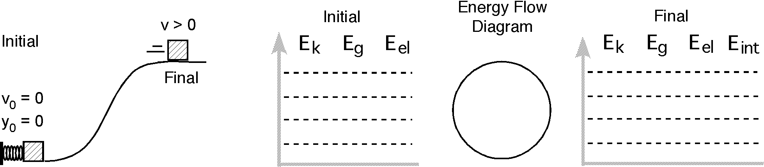

7. A bungee jumper falls off the platform and reaches the limit of stretch of the cord. Do two LOL diagrams for this problem. The first has the person, the cord and the earth in the system. The second has only the person and the earth in the system.

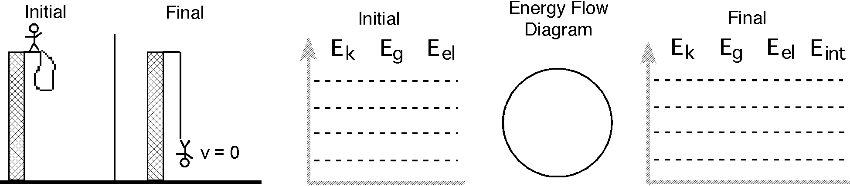

8. Superman, stopping a speeding locomotive, is pushed backwards a few meters in the process. The system is the locomotive and the earth.
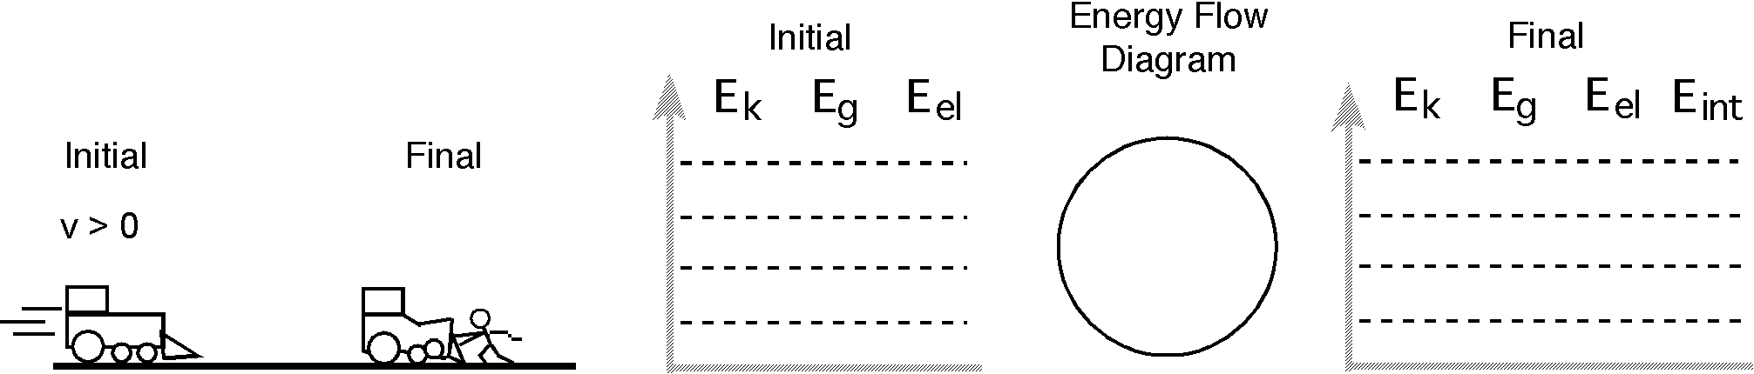

9. Create your own situation and construct corresponding energy bar graphs and system schema.

System = ______________________

