We will now conduct a “thought experiment” to determine the relationship between Energy Stored Kinetically and Velocity. Rather than collecting data, we will calculate data based on what we have already found to be true about both motion and energy.

Let’s consider a 300 gram tennis ball (yea, it’s a heavy tennis ball) that falls from a height of 1 meter. We have already considered this situation qualitatively, but we will now take a quantitative look.
1m

Use what you know about energy stored gravitationally, energy stored kinetically, and about bodies that are falling feely to complete the chart below. You will have to use the understanding that we have developed about the way that energy is stored and transferred.

Once you have a completed chart your “data collection” is complete. Use your data to produce a graph of energy stored kinetically in the ball vs. the velocity of the ball. You can make a graph by hand, or by using Excel or N-Spire.
height (m) | Eg (J) | Ek (J) | v (m/s)
1 | 2.940 | 0 | 0
.8 | 2.352 | 0.588 | 1.980
.6 | 1.764 | 1.176 | 2.800
.4 | 1.176 | 1.764 | 3.429
.2 | 0.588 | 2.352 | 3.960
0 | 0 | 2.940 | 4.427

The instant just before it touches the ground

Develop a mathematical model for the relationship between E_{k} and V of the tennis ball. Use dimensional analysis to determine the units of the slope (remember that a J = N•m and that a N = kg•m/s² ). Determine what the slope represents. What is the general model relating E_{k} and V?
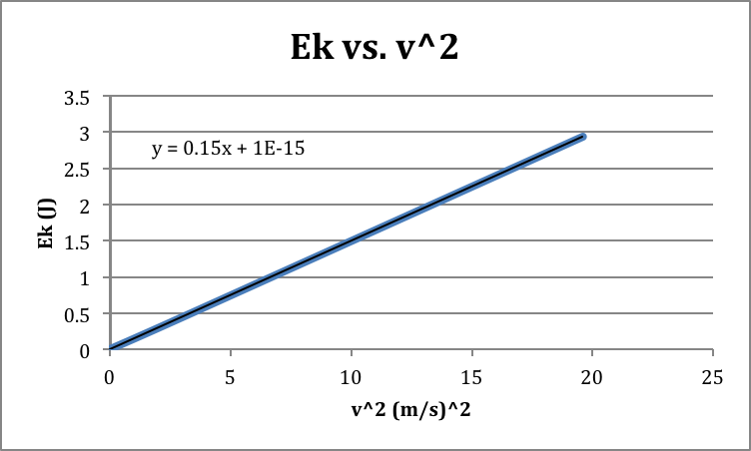
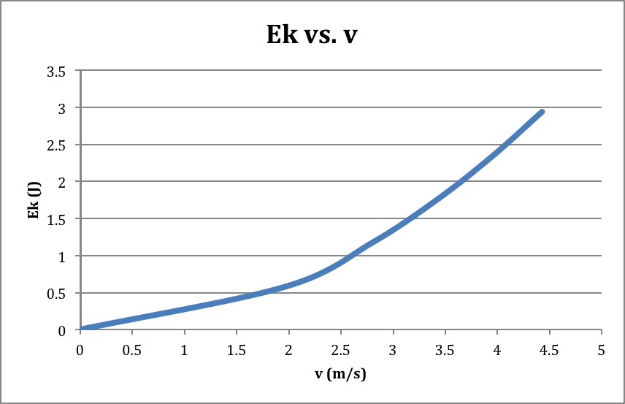

The first graph of E_{k} vs. v shows that E_{k} is proportional to v², so we make a second graph of E_{k} vs. v². This graph is linear, so we can develop a linear model in the form of y=mx+b. The equation from your nSpire should look something like y=0.15x+0. When we substitute the actual variables and units we get: E_{k}=(.15)v². The units work out to be . The cancel out, leaving kg as the units of the slope. This suggests that the slope is a mass or at least related to it. In this case the slope is .150kg, which is exactly one-half of the mass of .300kg. (It turns out that this slope will always be half the mass no matter what the mass is.) This allows us to generalize the equation to the following:
E_{k}=mv² → This is an equation for the energy at one given point in time, to get an equation for ΔE_{k} we can subtract the E_{k} at the initial state from the E_{k} at the final state. E_{kf} - E_{ki} = mv_{f}² - mv_{i}² → this can be simplified to our final model for energy stored elastically:
ΔE_{k} = m(v_{f}² - v_{i}²)

